# Extend a List - Python Exercise

Below is the image provided along with the recreated question, terminal output, and answer:

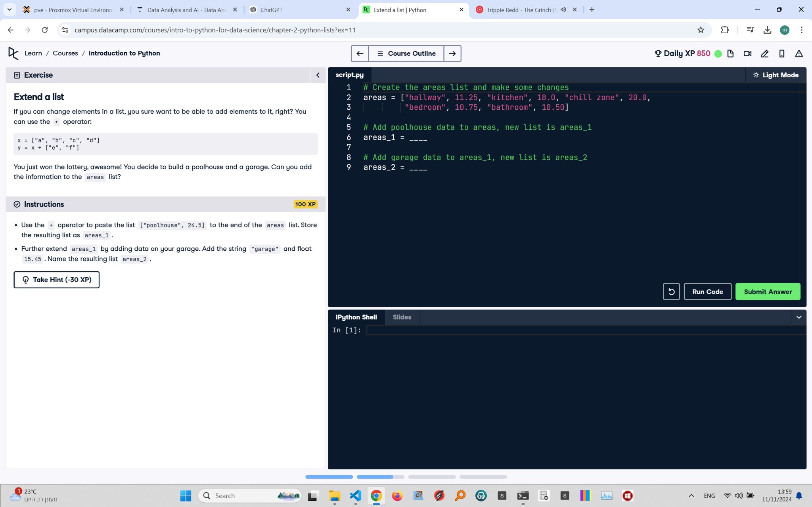

## Recreated Question and Terminal

Extend a List  
If you can change elements in a list, you sure want to be able to add elements to it, right? You can use the + operator:

x = ["a", "b", "c", "d"]  
y = x + ["e", "f"]

You just won the lottery, awesome! You decide to build a poolhouse and a garage. Can you add the information to the areas list?  
  
Instructions:  
- Use the + operator to paste the list ["poolhouse", 24.5] to the end of the areas list. Store the resulting list as areas_1.  
- Further extend areas_1 by adding data on your garage. Add the string "garage" and float 15.45. Name the resulting list areas_2.

## Answer

# Create the areas list and make some changes  
areas = ["hallway", 11.25, "kitchen", 18.0, "chill zone", 20.0, "bedroom", 10.75, "bathroom", 10.50]  
  
# Add poolhouse data to areas, new list is areas_1  
areas_1 = areas + ["poolhouse", 24.5]  
  
# Add garage data to areas_1, new list is areas_2  
areas_2 = areas_1 + ["garage", 15.45]  
  
# Print the updated lists  
print(areas_1)  
print(areas_2)

## Explanation of the Answer

The code extends the areas list using the + operator. areas_1 is created by appending ["poolhouse", 24.5] to areas. areas_2 is created by appending ["garage", 15.45] to areas_1. The updated lists are then printed, showing the new elements added to the original list.